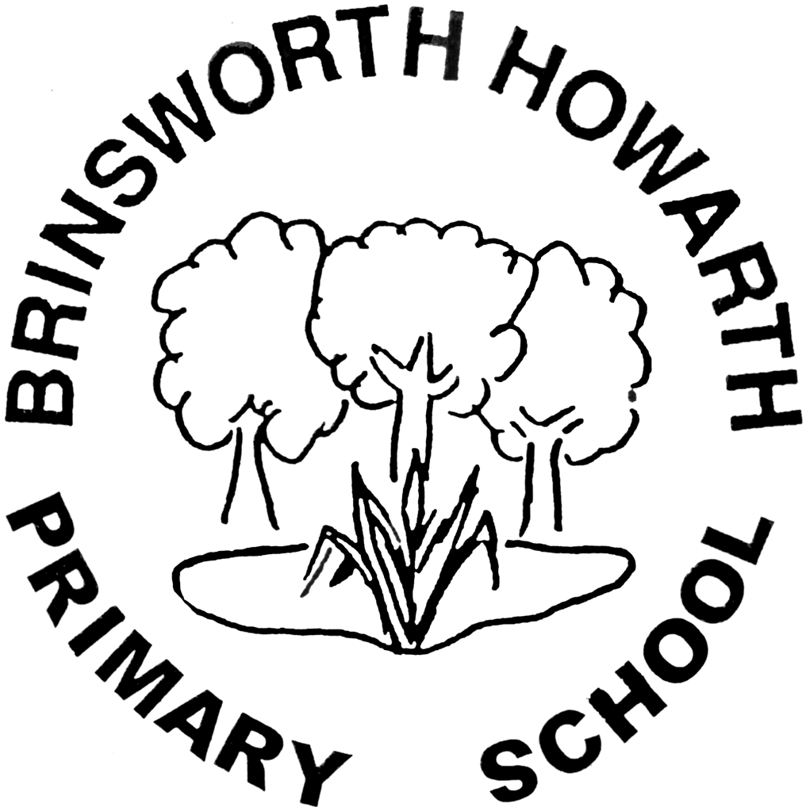

Design and Technology Policy
2019

Design and Technology Policy Sept 2019
What is DT?
"Technology makes possibilities. Design makes solutions."
John Maeda

Curriculum Intent

To prepare children to deal with our rapidly changing world.
To allow children to become creative problem solvers and thinkers.

It is the intent of Brinsworth Howarth that Design Technology is taught in all year groups through at least one topic per term, which includes one topic relating to food. Design Technology projects are often made cross curricular - linking to other subjects taught.

Key objectives of intent.
- Products are to be made for a purpose.
- Individuality should be ensured in children’s design and construction of products.
- Delivery of the two strands: Designing and Making and Cooking and Nutrition.
- Teaching the importance of making on-going changes and improvements during making stages.
- Looking into seasonality of ingredients and how they are grown, caught or reared.
- The introduction of computing and coding of products in KS2.
- Researching key events and individual designers in the History of Technology in KS2.
- Develop the creative, technical and practical expertise they need to perform everyday tasks confidently and to participate successfully in an increasingly technological world.
- Build and apply a repertoire of knowledge, understanding and skills in order to design and make high-quality prototypes and products for a wide range of users
- Critique, evaluate and test their ideas and products and the work of others
- Understand and apply the principles of nutrition and learn how to cook.

Curriculum Implementation
Across KS1 and KS2 DT is taught across five key areas:

- Cooking and Nutrition
- Mechanisms
- Structures
- Textiles
- Electrical systems (KS2 ONLY)

There are four strands that then run through each topic:

Design – Make- Evaluate-Technical Knowledge
- The teaching of Design Technology across the school follows the National Curriculum with the use of KAPOW planning as a structure which can be adapted using a cross-curricular approach – whilst maintaining the KAPOW progression of skills in each area and across the 4 strands.

- Children design products with a purpose in mind and an intended user of the products. Food technology is implemented across the school with children developing an understanding of where food comes from, the importance of a varied and healthy diet and how to prepare this.

Early Years Foundation Stage – continuous provision.

The most relevant early years outcomes for DT are taken from the following areas of learning:
- Physical Development
- Understanding the World
- Expressive Arts and Design

During the EYFS pupils explore and use a variety of media and materials through a combination of child initiated and adult directed activities. They have the opportunities to learn to:
- Use different media and materials to express their own ideas
- Use what they have learnt about media and materials in original ways, thinking about form, function and purpose
- Make plans and construct with a purpose in mind using a variety of resources
- Develop skills to use simple tools and techniques appropriately, effectively and safely
- Select appropriate resources for a product and adapt their work where necessary
- Cook and prepare food adhering to good health and hygiene routines

Curriculum Impact
- Assessment of children's learning in Design Technology is an ongoing monitoring of children's understanding, knowledge and skills by the class teacher in lessons. This assessment is then used to inform differentiation, support and challenge required by the children.

- Class teachers will report annually to parents on the progress made. The children are encouraged to assess their own work through discussion with their teacher and peers. Discovery books show the progression and breadth of study through the school.

- Design Technology is also monitored by the subject leader throughout the year in the form of book monitoring, looking at outcomes and pupil interviews to discuss their learning and understanding and establish the impact of the teaching taking place.

- EYFS pupils' progress and attainment is tracked using the Early Excellence Assessment tracker system, telling us whether each individual child is below expected, at expected or above expected attainment for their age.

Health and Safety
This is an essential part of teaching Design and Technology, at all times children must be taught and understand how to use and handle equipment and media safely, what to do in case of an emergency and how to be safe. Any potential dangers of working with certain medias and tools must be discussed with the children first, and should not prohibit their use by children. Teachers will ensure that issues of Health and Safety are addressed in the planning and delivery of the curriculum. Any risks are assessed by staff (refer to school risk assessments).

Food will be bought and used on the day if it is needed. Before undertaking a food technology activity a letter will be sent to parents outlining the activity if it involves tasting the food. The class teacher/ teacher assistant will ensure that equipment, table tops, cooker etc. are clean and in working order. Cleaning routines, including washing hands, will always be followed.

Updated by: Mrs K.Ford Review date: March 2021

