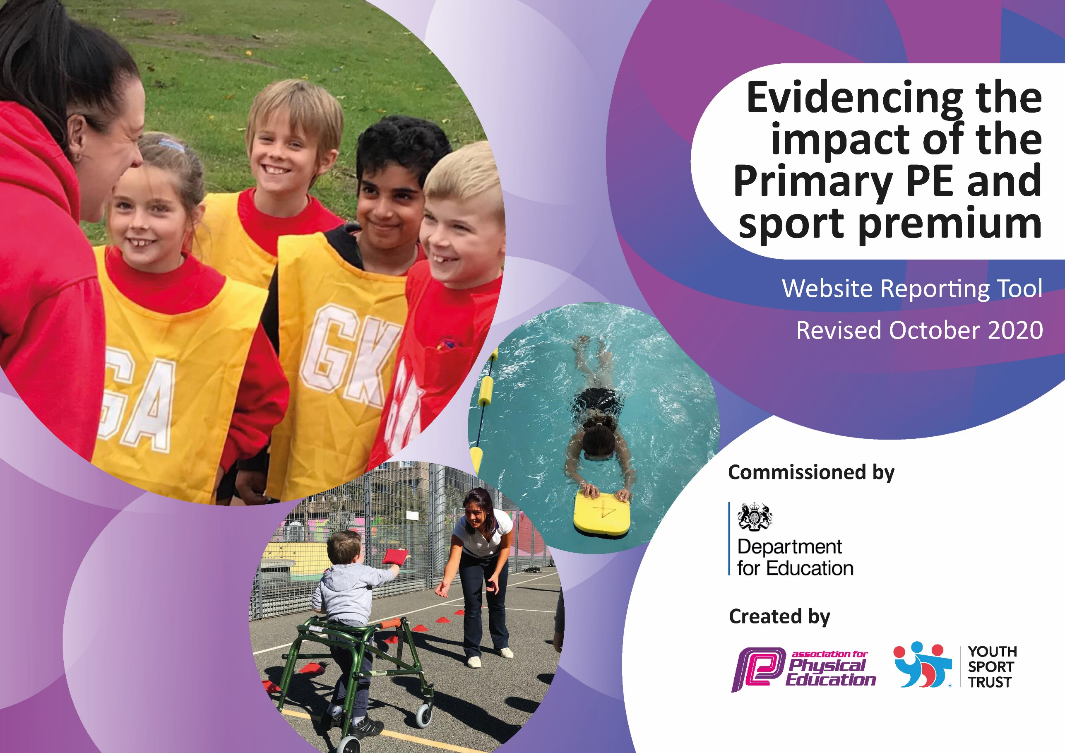
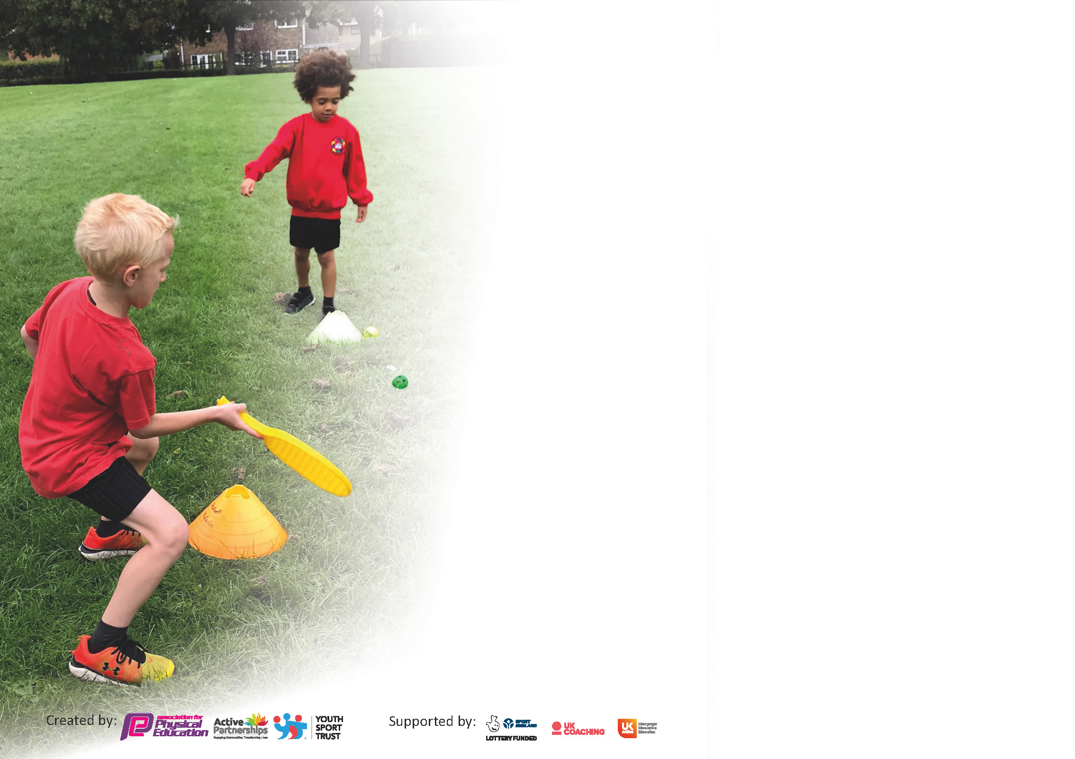

It is important that your grant is used effectively and based on school need. The Education Inspection Framework (Ofsted 2019 p64) makes clear there will be a focus on ‘whether leaders and those responsible for governors all understand their respective roles and perform these in a way that enhances the effectiveness of the school’.

Under the Quality of Education criteria (p41) inspectors consider the extent to which schools can articulate their curriculum (INTENT), construct their curriculum (IMPLEMENTATION) and demonstrate the outcomes which result (IMPACT).

To assist schools with common transferable language this template has been developed to utilise the same three headings which should make your plans easily transferable between working documents.

Schools must use the funding to make additional and sustainable improvements to the quality of Physical Education, School Sport and Physical Activity (PESSPA) they offer. This means that you should use
the Primary PE and sport premium to:

- Develop or add to the PESSPA activities that your school already offer
- Build capacity and capability within the school to ensure that improvements made now will benefit pupils joining the school in future years

Please visit gov.uk for the revised DfE guidance including the 5 key indicators across which schools should demonstrate an improvement. This document will help you to review your
provision and to report your spend. DfE encourages schools to use this template as an effective way of meeting the reporting requirements of the Primary PE and sport premium.

We recommend you start by reflecting on the impact of current provision and reviewing the previous spend.

Schools are required to publish details of how they spend this funding as well as on the impact it has on pupils’ PE and sport participation and attainment by the end of the summer term or by 31st July 2021 at the latest.

** In the case of any under-spend from 2019/20 which has been carried over this must be used and published by 31st March 2021.

We recommend regularly updating the table and publishing it on your website throughout the year. This evidences your ongoing self-evaluation of how you are using the funding to secure maximum, sustainable impact. Final copy must
be posted on your website by the end of the academic year and no later than the 31st July 2021. To see an example of how to complete the table please click HERE.
Created by: Supported by:

Please note: Although there has been considerable disruption in 2020 it is important that you publish details on your website of how you spend the funding - this is a legal requirement.
Support for review and reflection - considering the 5 key indicators from DfE, what development needs are a priority for your setting and your pupils now and why? Use the space below to reflect on previous spend and key achievements and areas for development.

N.B. In this section you should refer to any adjustments you might have made due to Covid-19 and how these will influence further improvement.
Key achievements to date until July 2020: | Areas for further improvement and baseline evidence of need:
- Increased participation in extra-curricular sports  - Increased active minutes within school time  - Support given for increased active minutes at home  - Increased participation in competitive sport (Intra and external)  - Increased staff confidence and training through the introduction of Real PE  - Assessment put in place and all class teachers trained in how to use assessment effectively  - Monitoring put in place of assessment  - Improvement in school equipment (full class sets)  - Winners of Rotherham ‘Beat the Street’ | - Embed new assessment and monitoring system with new class teachers  - Support new NQT in planning, delivering and assessment in PE  - Reintroduce a range of extra curricular active clubs, ensuring that these can be made inclusive  - Provide provision for youngest children to develop all-important early physical literacy skills they have missed out on during covid

Did you carry forward an underspend from 2019-20 academic year into the current academic year? YES/NO * Delete as applicable

If YES you must complete the following section
If NO, the following section is not applicable to you

If any funding from the academic year 2019/20 has been carried over you MUST complete the following section. Any carried over funding MUST be spent by 31 March 2021.
Academic Year: September 2020 to March 2021 | Total fund carried over: £6140.50 | Date Updated: | Aug/ Sep 2020
What Key indicator(s) are you going to focus on? |  |  |  | Total Carry Over Funding:
 |  |  |  | £6140.50
Intent | Implementation |  | Impact
Your school focus should be clear how you want to impact on your pupils.  See below. | Make sure your actions to achieve are linked to your intentions:  See below. | Carry over funding allocated: £6140.50 | Evidence of impact: How can you measure the impact on your pupils; you may have focussed on the difference that PE, SS & PA have made to pupils re-engagement with school. What has changed?:  See below. | Sustainability and suggested next steps and how does this link with the key indicators on which you are focussing this academic year?:  See below.

Meeting national curriculum requirements for swimming and water safety.

N.B Complete this section to your best ability. For example you might have practised safe self-rescue techniques on dry land.
What percentage of your current Year 6 cohort swim competently, confidently and proficiently over a distance of at least 25 metres?  N.B. Even though your pupils may swim in another year please report on their attainment on leaving primary school at the end of the summer term 2021. | 20/32  63%
What percentage of your current Year 6 cohort use a range of strokes effectively [for example, front crawl, backstroke and breaststroke]? | 16/32  50%
What percentage of your current Year 6 cohort perform safe self-rescue in different water-based situations? | 31/32  97%
Schools can choose to use the Primary PE and sport premium to provide additional provision for swimming but this must be for activity over and above the national curriculum requirements. Have you used it in this way? | No

Action Plan and Budget Tracking
Capture your intended annual spend against the 5 key indicators. Clarify the success criteria and evidence of impact that you intend to measure to evaluate for pupils today and for the future.

Academic Year: 2020/21 | Total fund allocated: £17990 (£24,130.50) | Date Updated: Aug/ September 2020
Key indicator 1: The engagement of all pupils in regular physical activity – Chief Medical Officers guidelines recommend that primary school pupils undertake at least 30 minutes of physical activity a day in school |  |  |  | Percentage of total allocation:
 |  |  |  | 81%
Intent | Implementation |  | Impact
Your school focus should be clear what you want the pupils to know and be able to do and about  what they need to learn and to  consolidate through practice: | Make sure your actions to achieve are linked to your intentions: | Funding allocated: | Evidence of impact: what do pupils now know and what can they now do? What has changed?: | Sustainability and suggested next steps:
- To engage our youngest children in regular exercise and activity to develop key physical skills in line with their age-related development.  - To reduce obesity in early years by setting positive healthy relationships with activity and promoting the importance of a healthy life-style. | Increase and improve the outdoor provision for FS and KS1, incorporating areas and apparatus for climbing, cycling, balancing and developing key gross motor skills inline with the new EYFS curriculum and catch up for KS1 pupils who have missed opportunities. | £19500.00  £19,500.00 (total) | Pupils will be able to and encouraged to access at-least 30 minutes of activity every day in a fun and engaging way. They will have appropriate equipment and apparatus to practise running, climbing, jumping, cycling in a safe and practical environment. | The new equipment and apparatus will remain in place for all further pupils joining FS and KS1 for many years to come to enable them to practise and gain skills towards their physical development and catch up on opportunities missed due to the pandemic.  Continue to use apparatus and equipment to support children in developing key early literacy skills in their early development and to engage and encourage them to be as active as possible during the early years.
Key indicator 2: The profile of PESSPA being raised across the school as a tool for whole school improvement |  |  |  | Percentage of total allocation:
 |  |  |  | %
Intent | Implementation |  | Impact
Your school focus should be clear what you want the pupils to know and be able to do and about  what they need to learn and to  consolidate through practice: | Make sure your actions to achieve are linked to your intentions: | Funding allocated: | Evidence of impact: what do pupils now know and what can they now do? What has changed?: | Sustainability and suggested next steps:
- To improve the outdoor and active provision within the FS and KS1 outdoor area. The improvements made to the new area will improve the profile of PESSPA across school by every new FS/KS1 cohort having access to develop their physical literacy skills in a fun, cross-curricular way. They will then be able to build on and develop these key skills as they progress through school, having a positive attitude towards activity and understanding about the importance of exercise and movement, as part of a healthy lifestyle. | As above. | As above. |  | As above.

Key indicator 3: Increased confidence, knowledge and skills of all staff in teaching PE and sport |  |  |  | Percentage of total allocation:
 |  |  |  | %
Intent | Implementation |  | Impact
Your school focus should be clear | Make sure your actions to | Funding | Evidence of impact: what do | Sustainability and suggested
what you want the pupils to know | achieve are linked to your | allocated: | pupils now know and what | next steps:
and be able to do and about | intentions: |  | can they now do? What has
what they need to learn and to |  |  | changed?:
consolidate through practice:
Key indicator 4: Broader experience of a range of sports and activities offered to all pupils |  |  |  | Percentage of total allocation:
 |  |  |  | 19%
Intent | Implementation |  | Impact
Your school focus should be clear | Make sure your actions to | Funding | Evidence of impact: what do | Sustainability and suggested
what you want the pupils to know | achieve are linked to your | allocated: | pupils now know and what | next steps:
and be able to do and about | intentions: |  | can they now do? What has
what they need to learn and to |  |  | changed?:
consolidate through practice:
- To provide opportunities for pupils to access to a variety of new sports/ activities and for pupils to engage in after extra curricular, linked to the 30-30 initiative.  - Engage parents through extra curricular.  - Target wider groups of children including girls, SEND and those children who wouldn’t usually engage.  To provide adequate equipment for full classes to engage in twice weekly P.E. sessions and all be active and engaged throughout.  To encourage pupils to spend their break times/ lunchtimes actively by providing new and interesting equipment for them to choose to use and explore being active in new and interesting ways. | To use ‘The Learners Trust’ extra curricular activities to run weekly activities linked to activity and sport to engage pupils and parents in further activity and a broader range of experiences.  Replace lost and broken equipment, to ensure that there is enough for classes of 30+ to fully engage in their P.E. lessons and to provide spare to be used outdoors at break times and lunch times. | £3500.00  £1127.50  £4,627.50 (total) | Extra curricular events were not able to go ahead due to covid.  Pupils in large classes all have access to equipment they need to fully engage in their P.E. lessons. There is now enough equipment that if two classes should happen to have P.E. at the same time, there is enough equipment to hold the lessons simultaneously, therefore ensuring enough timetable slots for every class to access 2 hours of P.E. per week.  New and different equipment has been purchased to introduce the children into new and more varied sports and games, targeting children who may not have previously engaged well in traditional sports. | New equipment is of good quality and should last for future classes coming through school. Staff to share good examples of games/ activities they have tried using the new equipment on the staff site for future reference.

Key indicator 5: Increased participation in competitive sport |  |  |  | Percentage of total allocation:
 |  |  |  | %
Intent | Implementation |  | Impact
Your school focus should be clear | Make sure your actions to | Funding | Evidence of impact: what do | Sustainability and suggested
what you want the pupils to know | achieve are linked to your | allocated: | pupils now know and what | next steps:
and be able to do and about | intentions: |  | can they now do? What has
what they need to learn and to |  |  | changed?:
consolidate through practice:

Signed off by
Head Teacher: | Maxine Crawford
Date: | 16.07.2021
Subject Leader: | Louise Hall
Date: | 16.7.21
Governor: | Mel Stubbs
Date: | 16.7.21

